| **Model Information** | |
| --- | --- |
| **Data Set** | WORK.RESP |
| **Response Variable** | V1 |
| **Number of Response Levels** | 2 |
| **Model** | binary logit |
| **Optimization Technique** | Fisher's scoring |

**STAT 448 HW#4 Solutions**

1)

Logistic Regression Model: V1 = Cent + Treat + Sex + Age + BL

| **Testing Global Null Hypothesis: BETA=0** | | | |
| --- | --- | --- | --- |
| **Test** | **Chi-Square** | **DF** | **Pr > ChiSq** |
| **Likelihood Ratio** | 38.8310 | 5 | <.0001 |
| **Score** | 34.4008 | 5 | <.0001 |
| **Wald** | 26.4298 | 5 | <.0001 |

| **Type 3 Analysis of Effects** | | | |
| --- | --- | --- | --- |
| **Effect** | **DF** | **Wald Chi-Square** | **Pr > ChiSq** |
| **Cent** | 1 | 1.8441 | 0.1745 |
| **Treat** | 1 | 5.2997 | 0.0213 |
| **Sex** | 1 | 0.0666 | 0.7963 |
| **Age** | 1 | 0.0944 | 0.7587 |
| **BL** | 1 | 20.9746 | <.0001 |

| **Analysis of Maximum Likelihood Estimates** | | | | | | |
| --- | --- | --- | --- | --- | --- | --- |
| **Parameter** |  | **DF** | **Estimate** | **Standard Error** | **Wald Chi-Square** | **Pr > ChiSq** |
| **Intercept** |  | 1 | 1.5061 | 0.8005 | 3.5400 | 0.0599 |
| **Cent** | **1** | 1 | -0.6728 | 0.4954 | 1.8441 | 0.1745 |
| **Treat** | **Active** | 1 | 1.1480 | 0.4987 | 5.2997 | 0.0213 |
| **Sex** | **Female** | 1 | -0.1592 | 0.6167 | 0.0666 | 0.7963 |
| **Age** |  | 1 | 0.00579 | 0.0189 | 0.0944 | 0.7587 |
| **BL** | **0** | 1 | -2.4437 | 0.5336 | 20.9746 | <.0001 |

a) Based on the significance of the global test, some of the beta parameters have a significant impact in the model. This indicates some of the variables are useful in explaining a patient’s respiratory status after the first visit. Furthermore, looking at type 3 analyses of the significance of parameter estimates, only treatment and baseline respiratory status have a significant impact in the model. This indicates it may be beneficial to only include a patient’s treatment and baseline respiratory status when trying to model their respiratory status after the first visit.

Logistic Regression Model: V1 = Treat + BL

| **Model Information** | |
| --- | --- |
| **Data Set** | WORK.RESP |
| **Response Variable** | V1 |
| **Number of Response Levels** | 2 |
| **Model** | binary logit |
| **Optimization Technique** | Fisher's scoring |

| **Analysis of Maximum Likelihood Estimates** | | | | | | |
| --- | --- | --- | --- | --- | --- | --- |
| **Parameter** |  | **DF** | **Estimate** | **Standard Error** | **Wald Chi-Square** | **Pr > ChiSq** |
| **Intercept** |  | 1 | 1.3774 | 0.4359 | 9.9841 | 0.0016 |
| **Treat** | **Active** | 1 | 1.1573 | 0.4787 | 5.8440 | 0.0156 |
| **BL** | **0** | 1 | -2.5663 | 0.5181 | 24.5386 | <.0001 |

| **Odds Ratio Estimates** | | | |
| --- | --- | --- | --- |
| **Effect** | **Point Estimate** | **95% Wald Confidence Limits** | |
| **Treat Active vs Placebo** | 3.181 | 1.245 | 8.131 |
| **BL 0 vs 1** | 0.077 | 0.028 | 0.212 |

b) Using backwards selection, the final model chosen includes treatment and baseline respiratory status: the only two significant variables from the full model. Based on the odds ratio estimates, a patient has 3.181 times higher odds to have a good respiratory status after the first visit if they receive the actual treatment compared to a placebo. Based on the 95% confidence interval, the true odds ratio is very likely between 1.245 and 8.131. Also, a patient’s odds to have a good respiratory status after the first visit if their baseline respiratory status is bad is .077 times the same odds if the baseline status is good. Based on the 95% confidence interval the true odds ratio is very likely between .028 and .212. Since these models cannot predict the exact odds ratios with 100% certainty, looking at the confidence intervals can give a general idea of what the odds ratios are likely to be. Overall, this model indicates having a good baseline status and taking treatment both significantly increase the odds of having a good respiratory status after the first visit.

2)

| **Model Information** | |
| --- | --- |
| **Data Set** | WORK.RESP |
| **Response Variable** | V4 |
| **Number of Response Levels** | 2 |
| **Model** | binary logit |
| **Optimization Technique** | Fisher's scoring |

| **Testing Global Null Hypothesis: BETA=0** | | | |
| --- | --- | --- | --- |
| **Test** | **Chi-Square** | **DF** | **Pr > ChiSq** |
| **Likelihood Ratio** | 34.1014 | 5 | <.0001 |
| **Score** | 30.5116 | 5 | <.0001 |
| **Wald** | 24.1066 | 5 | 0.0002 |

| **Type 3 Analysis of Effects** | | | |
| --- | --- | --- | --- |
| **Effect** | **DF** | **Wald Chi-Square** | **Pr > ChiSq** |
| **Cent** | 1 | 6.8866 | 0.0087 |
| **Treat** | 1 | 5.2361 | 0.0221 |
| **Sex** | 1 | 0.3096 | 0.5779 |
| **Age** | 1 | 2.7210 | 0.0990 |
| **BL** | 1 | 13.4665 | 0.0002 |

| **Analysis of Maximum Likelihood Estimates** | | | | | | |
| --- | --- | --- | --- | --- | --- | --- |
| **Parameter** |  | **DF** | **Estimate** | **Standard Error** | **Wald Chi-Square** | **Pr > ChiSq** |
| **Intercept** |  | 1 | 2.1604 | 0.7945 | 7.3940 | 0.0065 |
| **Cent** | **1** | 1 | -1.2740 | 0.4855 | 6.8866 | 0.0087 |
| **Treat** | **Active** | 1 | 1.0850 | 0.4742 | 5.2361 | 0.0221 |
| **Sex** | **Female** | 1 | 0.3348 | 0.6017 | 0.3096 | 0.5779 |
| **Age** |  | 1 | -0.0298 | 0.0181 | 2.7210 | 0.0990 |
| **BL** | **0** | 1 | -1.7256 | 0.4702 | 13.4665 | 0.0002 |

Logistic Regression Model: V4 = Cent + Treat + Sex + Age + BL

a) Analogous to the model in problem 1, the global null hypothesis test indicates there are some useful parameters in the model. Based on the type 3 analyses of the significance of parameter estimates, treatment, baseline respiratory status and the centre where the patient was treated are all statistically significant. In the model in problem 1, the centre where the patient was treated was not significant. This could indicate that over time, a patient’s treatment centre has a greater effect on their respiratory status. It appears the best model for respiratory status after the fourth visit will include the treatment, centre, baseline status and possibly age, as it is significant at a 10% level.

Logistic Regression Model: V4 = Cent + Treat + BL

| **Model Information** | |
| --- | --- |
| **Data Set** | WORK.RESP |
| **Response Variable** | V4 |
| **Number of Response Levels** | 2 |
| **Model** | binary logit |
| **Optimization Technique** | Fisher's scoring |

| **Analysis of Maximum Likelihood Estimates** | | | | | | |
| --- | --- | --- | --- | --- | --- | --- |
| **Parameter** |  | **DF** | **Estimate** | **Standard Error** | **Wald Chi-Square** | **Pr > ChiSq** |
| **Intercept** |  | 1 | 1.1861 | 0.4302 | 7.6013 | 0.0058 |
| **Cent** | **1** | 1 | -1.1006 | 0.4458 | 6.0953 | 0.0136 |
| **Treat** | **Active** | 1 | 1.0237 | 0.4532 | 5.1025 | 0.0239 |
| **BL** | **0** | 1 | -1.7286 | 0.4601 | 14.1120 | 0.0002 |

| **Odds Ratio Estimates** | | | |
| --- | --- | --- | --- |
| **Effect** | **Point Estimate** | **95% Wald Confidence Limits** | |
| **Cent 1 vs 2** | 0.333 | 0.139 | 0.797 |
| **Treat Active vs Placebo** | 2.783 | 1.145 | 6.766 |
| **BL 0 vs 1** | 0.178 | 0.072 | 0.437 |

b) Using backwards selection, the final model includes treatment, patient’s treatment centre and baseline status. This differs from the backward selection model in problem 1 where centre was not included. Based on the odds ratio estimates, a patient’s odds to have good respiratory status after the fourth visit if their treatment occurs in centre 1 is .333 times that for centre 2. The 95% confidence bounds for this odds ratio are .139 and .797. A patient has 2.783 times higher odds to have good status if they actually take treatment compared to the placebo. The 95% confidence bounds for this odds ratio are 1.145 and 6.776. Additionally, a patient’s odds of good respiratory status if their baseline status was bad is .178 times the odds to have good status if the baseline was good. The 95% confidence interval for this odds ratio contains values between .072 and .437. It’s also interesting to note that the significance of treatment and baseline status has decreased compared to the model for respiratory status after the first visit. Overall, this indicates being in centre 2, taking treatment and having a good baseline respiratory status all increase the odds of having good respiratory status after the fourth visit. It’s unclear what the differences are between the two centres, but over time the centre seems to have a greater effect on the patient as it was insignificant after the first visit, but significant after the fourth visit.

3)

Log-Linear Overdispersed Poisson Model: P2 = Treat + BL + Age

| **Model Information** | |
| --- | --- |
| **Data Set** | WORK.EPIL |
| **Distribution** | Poisson |
| **Link Function** | Log |
| **Dependent Variable** | P2 |

| **Criteria For Assessing Goodness Of Fit** | | | |
| --- | --- | --- | --- |
| **Criterion** | **DF** | **Value** | **Value/DF** |
| **Deviance** | 55 | 186.5068 | 3.3910 |
| **Scaled Deviance** | 55 | 55.0000 | 1.0000 |
| **Pearson Chi-Square** | 55 | 199.8615 | 3.6338 |
| **Scaled Pearson X2** | 55 | 58.9383 | 1.0716 |
| **Log Likelihood** |  | 209.3313 |  |
| **Full Log Likelihood** |  | -193.2839 |  |
| **AIC (smaller is better)** |  | 394.5678 |  |
| **AICC (smaller is better)** |  | 395.3085 |  |
| **BIC (smaller is better)** |  | 402.8779 |  |

| **Analysis Of Maximum Likelihood Parameter Estimates** | | | | | | | | |
| --- | --- | --- | --- | --- | --- | --- | --- | --- |
| **Parameter** |  | **DF** | **Estimate** | **Standard Error** | **Wald 95% Confidence Limits** | | **Wald Chi-Square** | **Pr > ChiSq** |
| **Intercept** |  | 1 | 1.0182 | 0.4483 | 0.1395 | 1.8968 | 5.16 | 0.0231 |
| **Treat** | 0 | 1 | 0.0766 | 0.1740 | -0.2645 | 0.4177 | 0.19 | 0.6598 |
| **Treat** | 1 | 0 | 0.0000 | 0.0000 | 0.0000 | 0.0000 | . | . |
| **BL** |  | 1 | 0.0202 | 0.0019 | 0.0165 | 0.0240 | 114.86 | <.0001 |
| **Age** |  | 1 | 0.0077 | 0.0147 | -0.0211 | 0.0365 | 0.27 | 0.6013 |
| **Scale** |  | 0 | 1.8415 | 0.0000 | 1.8415 | 1.8415 |  |  |

| **LR Statistics For Type 1 Analysis** | | | | | | | |
| --- | --- | --- | --- | --- | --- | --- | --- |
| **Source** | **Deviance** | **Num DF** | **Den DF** | **F Value** | **Pr > F** | **Chi-Square** | **Pr > ChiSq** |
| **Intercept** | 498.9551 |  |  |  |  |  |  |
| **Treat** | 498.9236 | 1 | 55 | 0.01 | 0.9236 | 0.01 | 0.9233 |
| **BL** | 187.4278 | 1 | 55 | 91.86 | <.0001 | 91.86 | <.0001 |
| **Age** | 186.5068 | 1 | 55 | 0.27 | 0.6043 | 0.27 | 0.6022 |

| **LR Statistics For Type 3 Analysis** | | | | | | |
| --- | --- | --- | --- | --- | --- | --- |
| **Source** | **Num DF** | **Den DF** | **F Value** | **Pr > F** | **Chi-Square** | **Pr > ChiSq** |
| **Treat** | 1 | 55 | 0.19 | 0.6616 | 0.19 | 0.6599 |
| **BL** | 1 | 55 | 89.25 | <.0001 | 89.25 | <.0001 |
| **Age** | 1 | 55 | 0.27 | 0.6043 | 0.27 | 0.6022 |

a) Since the scaled deviance is greater than 1, it appears the overdispersed Poisson model is appropriate to use. Based on the type 1 and type 3 analyses, it appears only baseline seizure count is significant to model the number of seizures in the second period. Furthermore, the parameter estimates show that only baseline seizure count is statistically significant. This indicates treatment is not effective in modeling the number of seizures in the second period and in fact, it is the most statistically insignificant predictor. Therefore, only the baseline seizure count should be kept in the final model and based on the parameter estimate, higher baseline seizure count corresponds to a higher seizure count in the second period.

Log-Linear Overdispersed Poisson Model: P2 = BL

| **Model Information** | |
| --- | --- |
| **Data Set** | WORK.EPIL |
| **Distribution** | Poisson |
| **Link Function** | Log |
| **Dependent Variable** | P2 |

| **Criteria For Assessing Goodness Of Fit** | | | |
| --- | --- | --- | --- |
| **Criterion** | **DF** | **Value** | **Value/DF** |
| **Deviance** | 57 | 188.6005 | 3.3088 |
| **Scaled Deviance** | 57 | 57.0000 | 1.0000 |
| **Pearson Chi-Square** | 57 | 198.8792 | 3.4891 |
| **Scaled Pearson X2** | 57 | 60.1065 | 1.0545 |
| **Log Likelihood** |  | 214.2186 |  |
| **Full Log Likelihood** |  | -194.3308 |  |
| **AIC (smaller is better)** |  | 392.6615 |  |
| **AICC (smaller is better)** |  | 392.8758 |  |
| **BIC (smaller is better)** |  | 396.8166 |  |

| **Analysis Of Maximum Likelihood Parameter Estimates** | | | | | | | |
| --- | --- | --- | --- | --- | --- | --- | --- |
| **Parameter** | **DF** | **Estimate** | **Standard Error** | **Wald 95% Confidence Limits** | | **Wald Chi-Square** | **Pr > ChiSq** |
| **Intercept** | 1 | 1.2910 | 0.1299 | 1.0363 | 1.5456 | 98.72 | <.0001 |
| **BL** | 1 | 0.0198 | 0.0017 | 0.0164 | 0.0232 | 129.30 | <.0001 |
| **Scale** | 0 | 1.8190 | 0.0000 | 1.8190 | 1.8190 |  |  |

| **LR Statistics For Type 1 Analysis** | | | | | | | |
| --- | --- | --- | --- | --- | --- | --- | --- |
| **Source** | **Deviance** | **Num DF** | **Den DF** | **F Value** | **Pr > F** | **Chi-Square** | **Pr > ChiSq** |
| **Intercept** | 498.9551 |  |  |  |  |  |  |
| **BL** | 188.6005 | 1 | 57 | 93.80 | <.0001 | 93.80 | <.0001 |

| **LR Statistics For Type 3 Analysis** | | | | | | |
| --- | --- | --- | --- | --- | --- | --- |
| **Source** | **Num DF** | **Den DF** | **F Value** | **Pr > F** | **Chi-Square** | **Pr > ChiSq** |
| **BL** | 1 | 57 | 93.80 | <.0001 | 93.80 | <.0001 |

b) Since the scaled deviance is greater than 1, it is appropriate to use an overdispersed Poisson model. Baseline seizure count is very statistically significant in modeling number of seizures in the second period and based on its parameter estimate, every 1 increase in baseline seizure corresponds to a e^(.0198) or 1.012 times increase in seizures in the second period. Overall, this model indicates baseline seizures are the only significant variable to model seizures in the second period. Therefore, the treatment progabide does not significantly affect seizure counts in the second period.

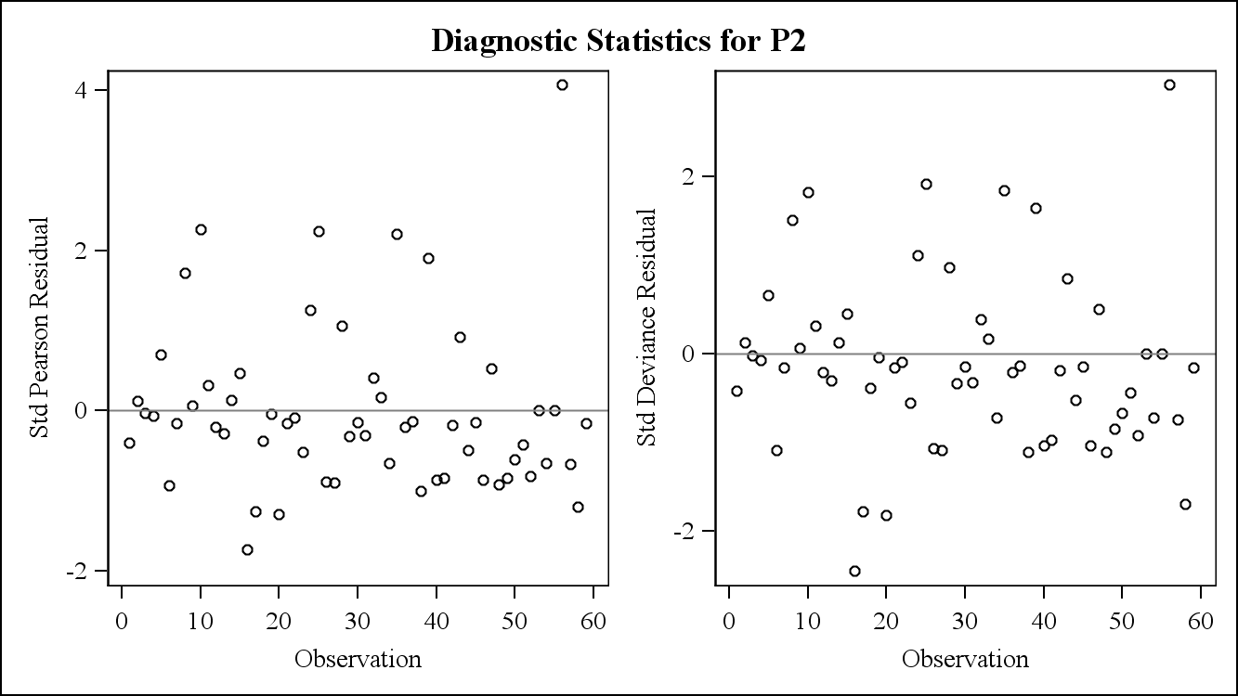

The residuals in both plots appear to be reasonably distributed around 0. Therefore, this indicates there are no problems with model assumptions.

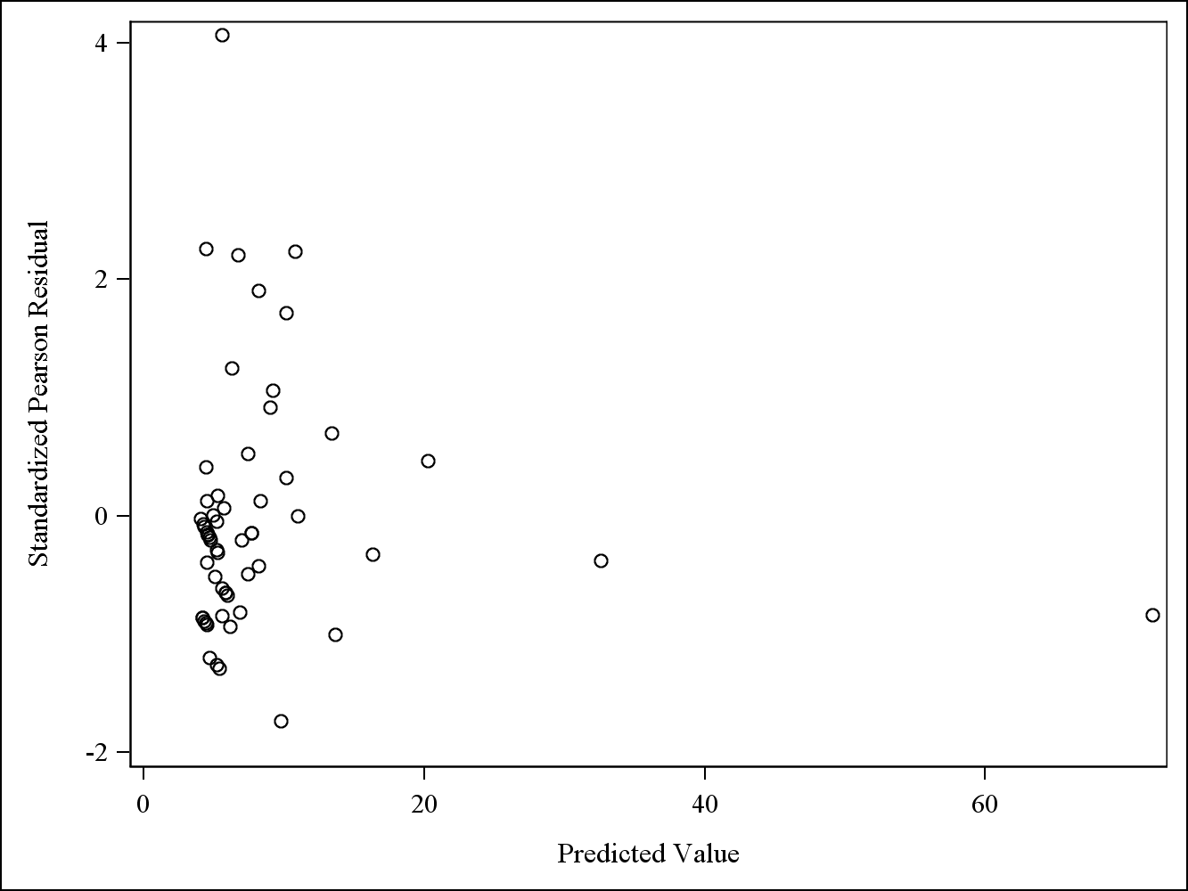

Since there are a few very large predicted values, it’s difficult to discern whether there are any trends in the residuals. Therefore, the plot will be constructed again with predicted values less than 20.

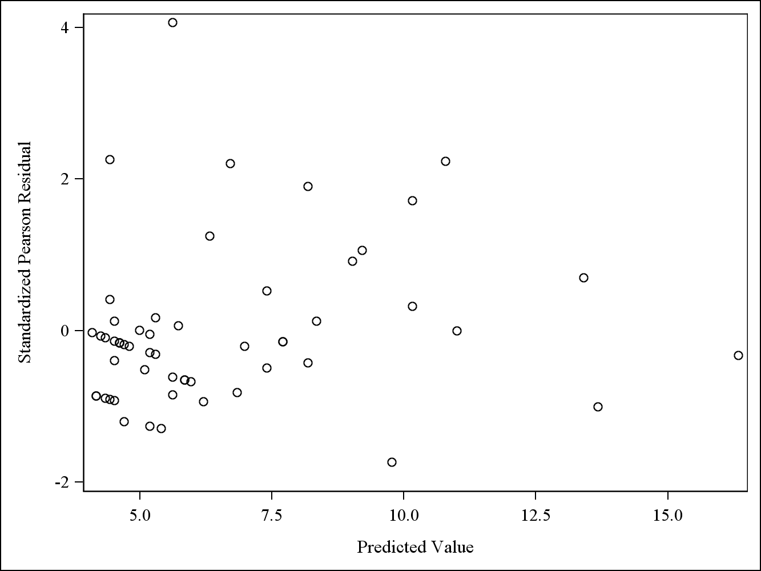

There do not appear to be any major trends in the Pearson residual vs predicted value plot. This indicates there are no problems with model assumptions.

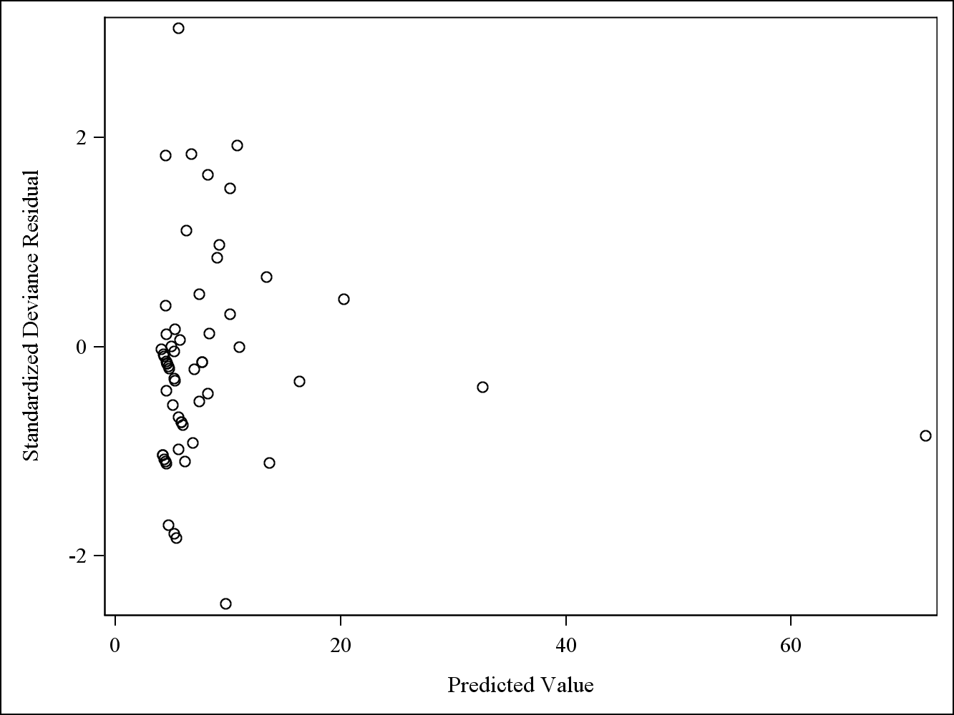

Similar to the previous plot, since there are a few very large predicted values, it’s difficult to discern whether there are any trends in the residuals. Therefore, the plot will be constructed again with predicted values less than 20.

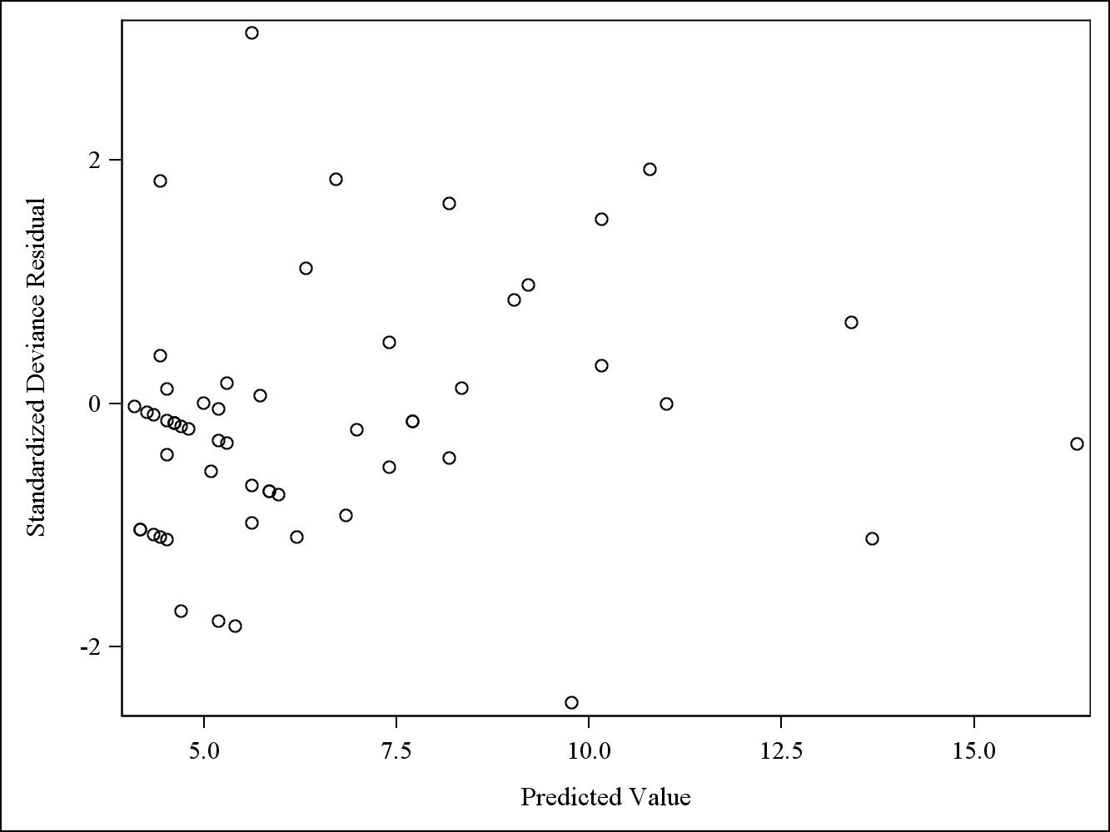

There does appear to be a slight upward trend of deviance residuals vs predicted values. This could indicate some potential problems with model assumptions.

4)

| **Model Information** | |
| --- | --- |
| **Data Set** | WORK.EPIL |
| **Distribution** | Poisson |
| **Link Function** | Log |
| **Dependent Variable** | P4 |

| **Criteria For Assessing Goodness Of Fit** | | | |
| --- | --- | --- | --- |
| **Criterion** | **DF** | **Value** | **Value/DF** |
| **Deviance** | 55 | 147.0216 | 2.6731 |
| **Scaled Deviance** | 55 | 55.0000 | 1.0000 |
| **Pearson Chi-Square** | 55 | 136.6408 | 2.4844 |
| **Scaled Pearson X2** | 55 | 51.1166 | 0.9294 |
| **Log Likelihood** |  | 220.9730 |  |
| **Full Log Likelihood** |  | -167.3950 |  |
| **AIC (smaller is better)** |  | 342.7900 |  |
| **AICC (smaller is better)** |  | 343.5307 |  |
| **BIC (smaller is better)** |  | 351.1002 |  |

Log-Linear Overdispersed Poisson Model: P4 = Treat + BL + Age

| **Analysis Of Maximum Likelihood Parameter Estimates** | | | | | | | | |
| --- | --- | --- | --- | --- | --- | --- | --- | --- |
| **Parameter** |  | **DF** | **Estimate** | **Standard Error** | **Wald 95% Confidence Limits** | | **Wald Chi-Square** | **Pr > ChiSq** |
| **Intercept** |  | 1 | 0.5051 | 0.4313 | -0.3402 | 1.3504 | 1.37 | 0.2415 |
| **Treat** | 0 | 1 | 0.2705 | 0.1666 | -0.0560 | 0.5969 | 2.64 | 0.1044 |
| **Treat** | 1 | 0 | 0.0000 | 0.0000 | 0.0000 | 0.0000 | . | . |
| **BL** |  | 1 | 0.0221 | 0.0018 | 0.0186 | 0.0255 | 153.66 | <.0001 |
| **Age** |  | 1 | 0.0140 | 0.0140 | -0.0135 | 0.0415 | 1.00 | 0.3168 |
| **Scale** |  | 0 | 1.6350 | 0.0000 | 1.6350 | 1.6350 |  |  |

| **LR Statistics For Type 1 Analysis** | | | | | | | |
| --- | --- | --- | --- | --- | --- | --- | --- |
| **Source** | **Deviance** | **Num DF** | **Den DF** | **F Value** | **Pr > F** | **Chi-Square** | **Pr > ChiSq** |
| **Intercept** | 476.2487 |  |  |  |  |  |  |
| **Treat** | 473.0840 | 1 | 55 | 1.18 | 0.2813 | 1.18 | 0.2766 |
| **BL** | 149.6763 | 1 | 55 | 120.99 | <.0001 | 120.99 | <.0001 |
| **Age** | 147.0216 | 1 | 55 | 0.99 | 0.3233 | 0.99 | 0.3190 |

| **LR Statistics For Type 3 Analysis** | | | | | | |
| --- | --- | --- | --- | --- | --- | --- |
| **Source** | **Num DF** | **Den DF** | **F Value** | **Pr > F** | **Chi-Square** | **Pr > ChiSq** |
| **Treat** | 1 | 55 | 2.65 | 0.1093 | 2.65 | 0.1036 |
| **BL** | 1 | 55 | 119.99 | <.0001 | 119.99 | <.0001 |
| **Age** | 1 | 55 | 0.99 | 0.3233 | 0.99 | 0.3190 |

a) Similar to the model in problem 3, the scaled deviance is greater than 1 so it is appropriate to use an overdispersed Poisson model. Based on type 1 and type 3 error, it appears only baseline seizure count is significant to model the number of seizures in the fourth period. Based on the parameter estimates, only baseline seizure count is significant and as baseline seizure count increases so does expected seizure count in the fourth period. This is analogous to the model with number of seizures in the second period. However, in this model, treatment is nearly significant at a 10% level; much more significant than the previous model. This could indicate the treatment starts to improve over time. Since treatment is nearly statistically significant at a 10%, and it is a variable of great interest, another model will be fitted with only treatment and baseline seizure count to see if treatment becomes statistically significant.

Log-Linear Overdispersed Poisson Model: P4 = Treat + BL

| **Model Information** | |
| --- | --- |
| **Data Set** | WORK.EPIL |
| **Distribution** | Poisson |
| **Link Function** | Log |
| **Dependent Variable** | P4 |

| **Criteria For Assessing Goodness Of Fit** | | | |
| --- | --- | --- | --- |
| **Criterion** | **DF** | **Value** | **Value/DF** |
| **Deviance** | 56 | 149.6763 | 2.6728 |
| **Scaled Deviance** | 56 | 56.0000 | 1.0000 |
| **Pearson Chi-Square** | 56 | 141.4367 | 2.5257 |
| **Scaled Pearson X2** | 56 | 52.9172 | 0.9450 |
| **Log Likelihood** |  | 220.5036 |  |
| **Full Log Likelihood** |  | -168.7224 |  |
| **AIC (smaller is better)** |  | 343.4447 |  |
| **AICC (smaller is better)** |  | 343.8811 |  |
| **BIC (smaller is better)** |  | 349.6773 |  |

| **Analysis Of Maximum Likelihood Parameter Estimates** | | | | | | | | |
| --- | --- | --- | --- | --- | --- | --- | --- | --- |
| **Parameter** |  | **DF** | **Estimate** | **Standard Error** | **Wald 95% Confidence Limits** | | **Wald Chi-Square** | **Pr > ChiSq** |
| **Intercept** |  | 1 | 0.8996 | 0.1650 | 0.5762 | 1.2230 | 29.73 | <.0001 |
| **Treat** | 0 | 1 | 0.3152 | 0.1610 | -0.0004 | 0.6307 | 3.83 | 0.0503 |
| **Treat** | 1 | 0 | 0.0000 | 0.0000 | 0.0000 | 0.0000 | . | . |
| **BL** |  | 1 | 0.0215 | 0.0017 | 0.0182 | 0.0249 | 160.83 | <.0001 |
| **Scale** |  | 0 | 1.6349 | 0.0000 | 1.6349 | 1.6349 |  |  |

| **LR Statistics For Type 1 Analysis** | | | | | | | |
| --- | --- | --- | --- | --- | --- | --- | --- |
| **Source** | **Deviance** | **Num DF** | **Den DF** | **F Value** | **Pr > F** | **Chi-Square** | **Pr > ChiSq** |
| **Intercept** | 476.2487 |  |  |  |  |  |  |
| **Treat** | 473.0840 | 1 | 56 | 1.18 | 0.2812 | 1.18 | 0.2765 |
| **BL** | 149.6763 | 1 | 56 | 121.00 | <.0001 | 121.00 | <.0001 |

| **LR Statistics For Type 3 Analysis** | | | | | | |
| --- | --- | --- | --- | --- | --- | --- |
| **Source** | **Num DF** | **Den DF** | **F Value** | **Pr > F** | **Chi-Square** | **Pr > ChiSq** |
| **Treat** | 1 | 56 | 3.84 | 0.0550 | 3.84 | 0.0500 |
| **BL** | 1 | 56 | 121.00 | <.0001 | 121.00 | <.0001 |

Based on type 1 analysis, treatment is still insignificant. However, looking at type 3 analyses and the parameter estimate, treatment is significant at a 10% level and nearly at a 5% level. Therefore, depending on what level of significance is used in the final model, either treatment and baseline seizure count or only baseline seizure count will be appropriate in the final model. Part b will be done using both models.

| **Model Information** | |
| --- | --- |
| **Data Set** | WORK.EPIL |
| **Distribution** | Poisson |
| **Link Function** | Log |
| **Dependent Variable** | P4 |

| **Criteria For Assessing Goodness Of Fit** | | | |
| --- | --- | --- | --- |
| **Criterion** | **DF** | **Value** | **Value/DF** |
| **Deviance** | 57 | 159.9413 | 2.8060 |
| **Scaled Deviance** | 57 | 57.0000 | 1.0000 |
| **Pearson Chi-Square** | 57 | 151.2008 | 2.6526 |
| **Scaled Pearson X2** | 57 | 53.8851 | 0.9454 |
| **Log Likelihood** |  | 208.2074 |  |
| **Full Log Likelihood** |  | -173.8548 |  |
| **AIC (smaller is better)** |  | 351.7097 |  |
| **AICC (smaller is better)** |  | 351.9240 |  |
| **BIC (smaller is better)** |  | 355.8648 |  |

| **Analysis Of Maximum Likelihood Parameter Estimates** | | | | | | | |
| --- | --- | --- | --- | --- | --- | --- | --- |
| **Parameter** | **DF** | **Estimate** | **Standard Error** | **Wald 95% Confidence Limits** | | **Wald Chi-Square** | **Pr > ChiSq** |
| **Intercept** | 1 | 1.0897 | 0.1295 | 0.8360 | 1.3435 | 70.84 | <.0001 |
| **BL** | 1 | 0.0209 | 0.0017 | 0.0176 | 0.0242 | 156.27 | <.0001 |
| **Scale** | 0 | 1.6751 | 0.0000 | 1.6751 | 1.6751 |  |  |

| **LR Statistics For Type 1 Analysis** | | | | | | | |
| --- | --- | --- | --- | --- | --- | --- | --- |
| **Source** | **Deviance** | **Num DF** | **Den DF** | **F Value** | **Pr > F** | **Chi-Square** | **Pr > ChiSq** |
| **Intercept** | 476.2487 |  |  |  |  |  |  |
| **BL** | 159.9413 | 1 | 57 | 112.73 | <.0001 | 112.73 | <.0001 |

| **LR Statistics For Type 3 Analysis** | | | | | | |
| --- | --- | --- | --- | --- | --- | --- |
| **Source** | **Num DF** | **Den DF** | **F Value** | **Pr > F** | **Chi-Square** | **Pr > ChiSq** |
| **BL** | 1 | 57 | 112.73 | <.0001 | 112.73 | <.0001 |

Log-Linear Overdispersed Poisson Model: P4 = BL

b) This model is extremely similar to the one for seizures in the second period. Baseline seizure count is statistically significant and based on its parameter estimate, every 1 increase in baseline seizures corresponds to a e^(.0209) or a 1.021 times increase in seizure counts in the fourth period. Treatment is not included in this model, indicating it did not have a statistically significant effect at a 5% level on the seizure counts.

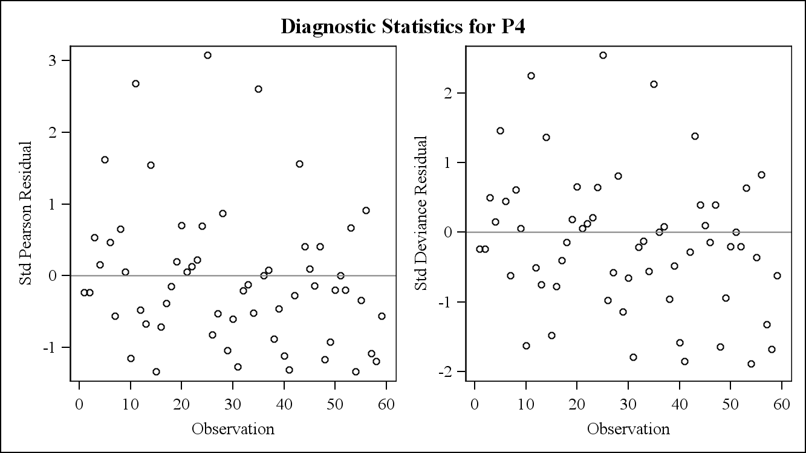

The residuals in both plots appear to be reasonably distributed around 0, indicating there are no problems with model assumptions.

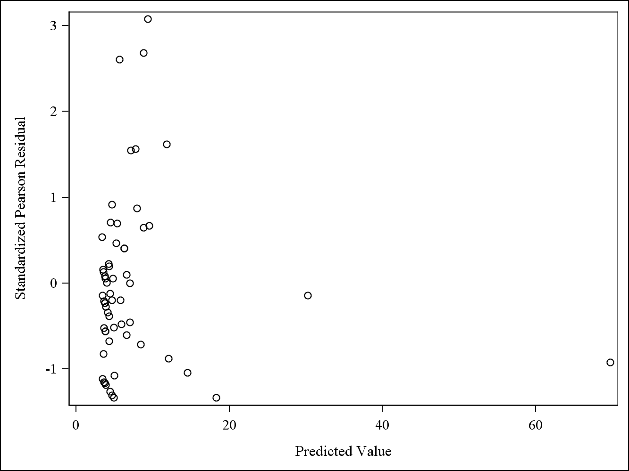

Since there are a few very large predicted values, it’s difficult to discern whether there are any trends in the residuals. Therefore, the plot will be constructed again with predicted values less than 20.

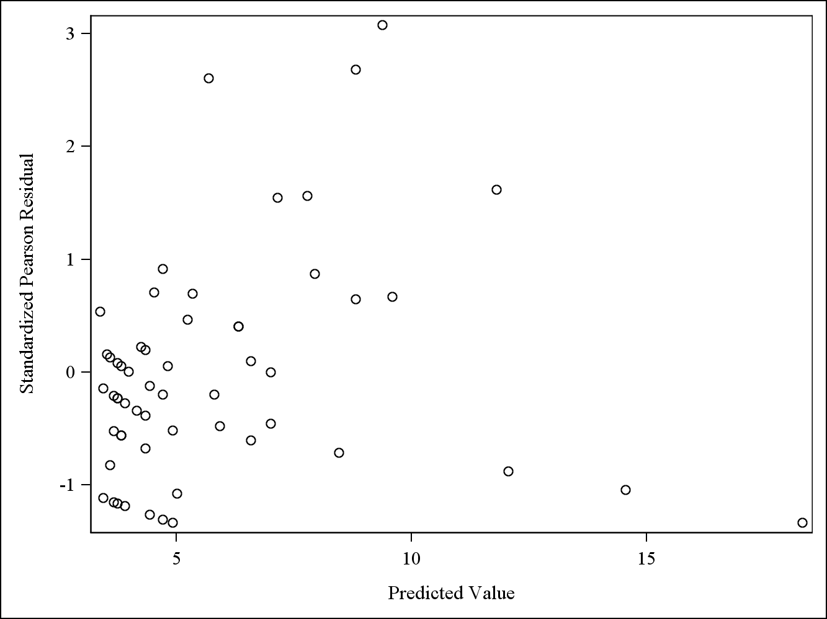

There does appear to be a slight upward trend of Perason residuals vs predicted values, which could indicate some potential problems with model assumptions.

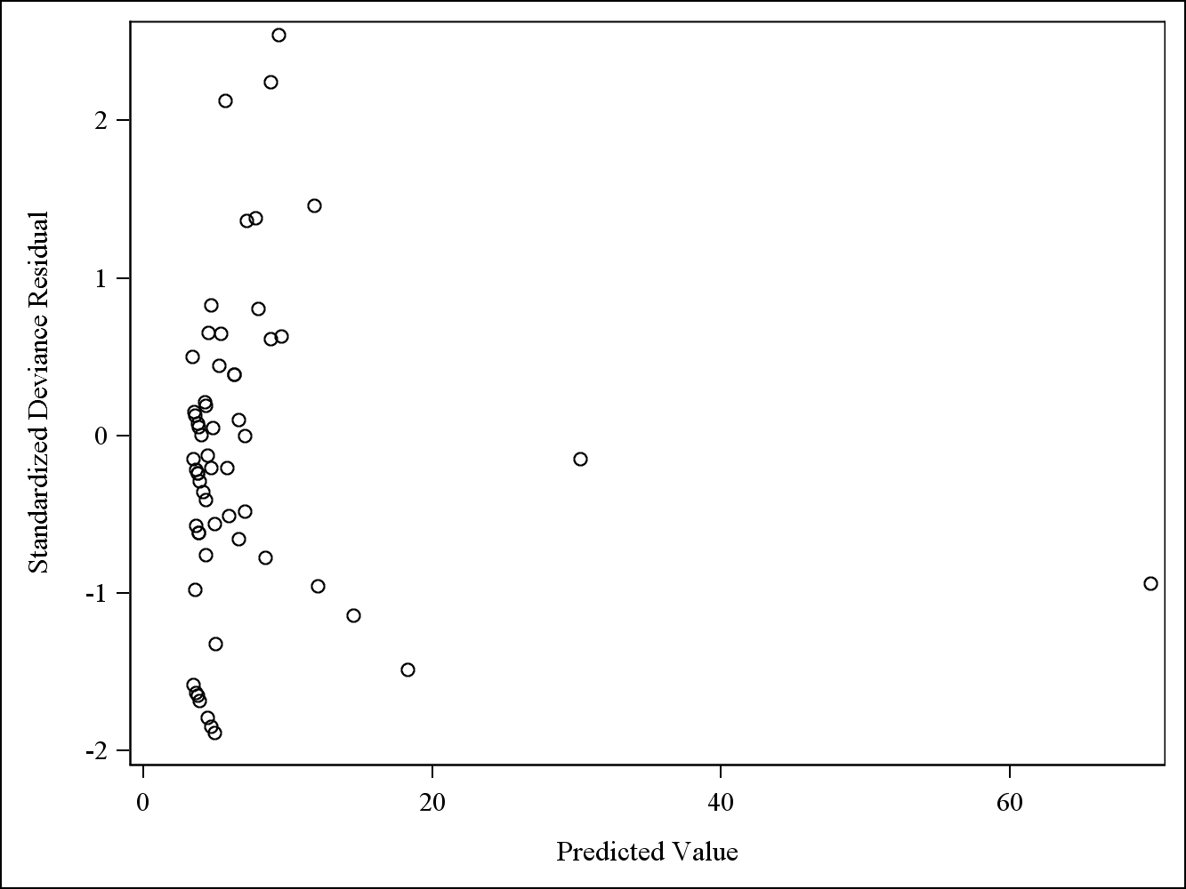

Since there are a few very large predicted values, it’s difficult to discern whether there are any trends in the residuals. The plot will be constructed again with predicted values less than 20.

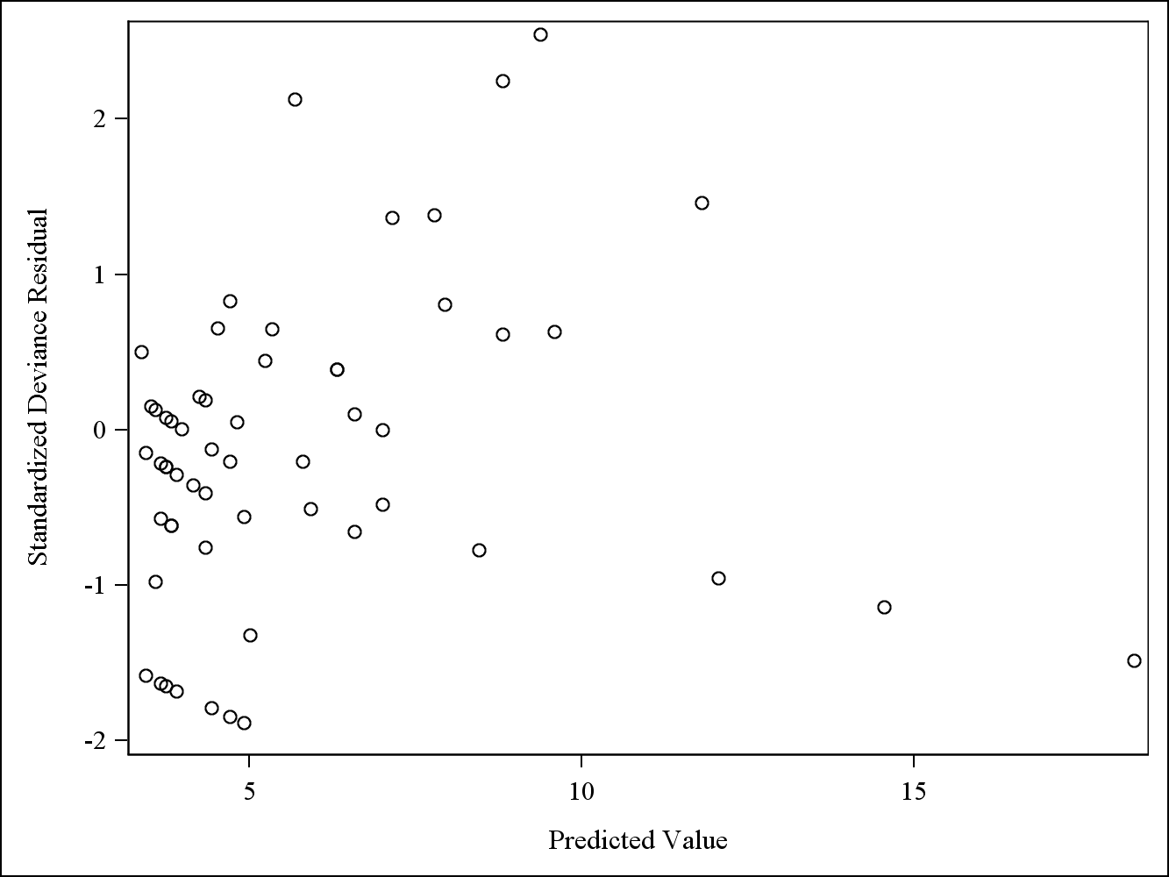

Similar to the Pearson residual plot, the deviance residual vs predicted value plot also appears to have a slight upward trend of residual values as predicted values increase. This could indicate some problems with model assumptions.

Log-Linear Overdispersed Poisson Model: P4 = BL + Treat

| **Model Information** | |
| --- | --- |
| **Data Set** | WORK.EPIL |
| **Distribution** | Poisson |
| **Link Function** | Log |
| **Dependent Variable** | P4 |

| **Criteria For Assessing Goodness Of Fit** | | | |
| --- | --- | --- | --- |
| **Criterion** | **DF** | **Value** | **Value/DF** |
| **Deviance** | 56 | 149.6763 | 2.6728 |
| **Scaled Deviance** | 56 | 56.0000 | 1.0000 |
| **Pearson Chi-Square** | 56 | 141.4367 | 2.5257 |
| **Scaled Pearson X2** | 56 | 52.9172 | 0.9450 |
| **Log Likelihood** |  | 220.5036 |  |
| **Full Log Likelihood** |  | -168.7224 |  |
| **AIC (smaller is better)** |  | 343.4447 |  |
| **AICC (smaller is better)** |  | 343.8811 |  |
| **BIC (smaller is better)** |  | 349.6773 |  |

| **Analysis Of Maximum Likelihood Parameter Estimates** | | | | | | | | |
| --- | --- | --- | --- | --- | --- | --- | --- | --- |
| **Parameter** |  | **DF** | **Estimate** | **Standard Error** | **Wald 95% Confidence Limits** | | **Wald Chi-Square** | **Pr > ChiSq** |
| **Intercept** |  | 1 | 0.8996 | 0.1650 | 0.5762 | 1.2230 | 29.73 | <.0001 |
| **BL** |  | 1 | 0.0215 | 0.0017 | 0.0182 | 0.0249 | 160.83 | <.0001 |
| **Treat** | 0 | 1 | 0.3152 | 0.1610 | -0.0004 | 0.6307 | 3.83 | 0.0503 |
| **Treat** | 1 | 0 | 0.0000 | 0.0000 | 0.0000 | 0.0000 | . | . |
| **Scale** |  | 0 | 1.6349 | 0.0000 | 1.6349 | 1.6349 |  |  |

| **LR Statistics For Type 1 Analysis** | | | | | | | |
| --- | --- | --- | --- | --- | --- | --- | --- |
| **Source** | **Deviance** | **Num DF** | **Den DF** | **F Value** | **Pr > F** | **Chi-Square** | **Pr > ChiSq** |
| **Intercept** | 476.2487 |  |  |  |  |  |  |
| **BL** | 159.9413 | 1 | 56 | 118.34 | <.0001 | 118.34 | <.0001 |
| **Treat** | 149.6763 | 1 | 56 | 3.84 | 0.0550 | 3.84 | 0.0500 |

| **LR Statistics For Type 3 Analysis** | | | | | | |
| --- | --- | --- | --- | --- | --- | --- |
| **Source** | **Num DF** | **Den DF** | **F Value** | **Pr > F** | **Chi-Square** | **Pr > ChiSq** |
| **BL** | 1 | 56 | 121.00 | <.0001 | 121.00 | <.0001 |
| **Treat** | 1 | 56 | 3.84 | 0.0550 | 3.84 | 0.0500 |

As previously discussed, it would be reasonable to keep treatment in the model at a 10% level of significance. This is different from the model for seizure counts after two periods, where treatment was very insignificant. Holding baseline seizure count constant, having placebo rather than progabide corresponds to e^(.3152) or 1.37 times increase in seizure counts. Similarly, holding treatment constant, every 1 increase in baseline seizures corresponds to e^(.0215) or a 1.022 times increase in seizure counts in the fourth period. Based on this final model, undergoing the treatment and having a low baseline seizure count corresponds to a lower number of seizures during the fourth period.

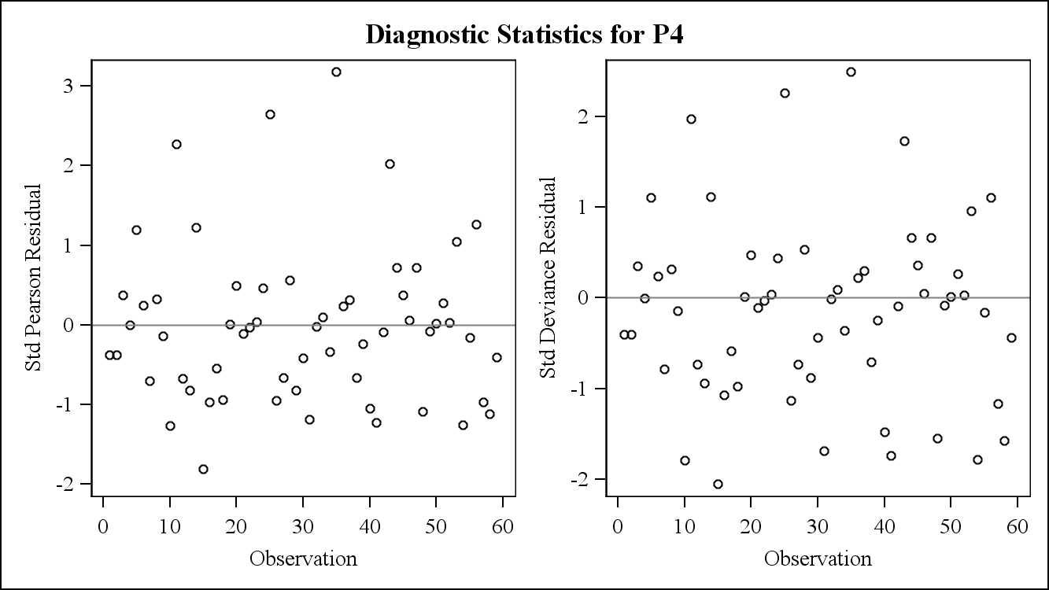

The residuals in both plots appear to be reasonably distributed around 0, indicating there are no problems with model assumptions.

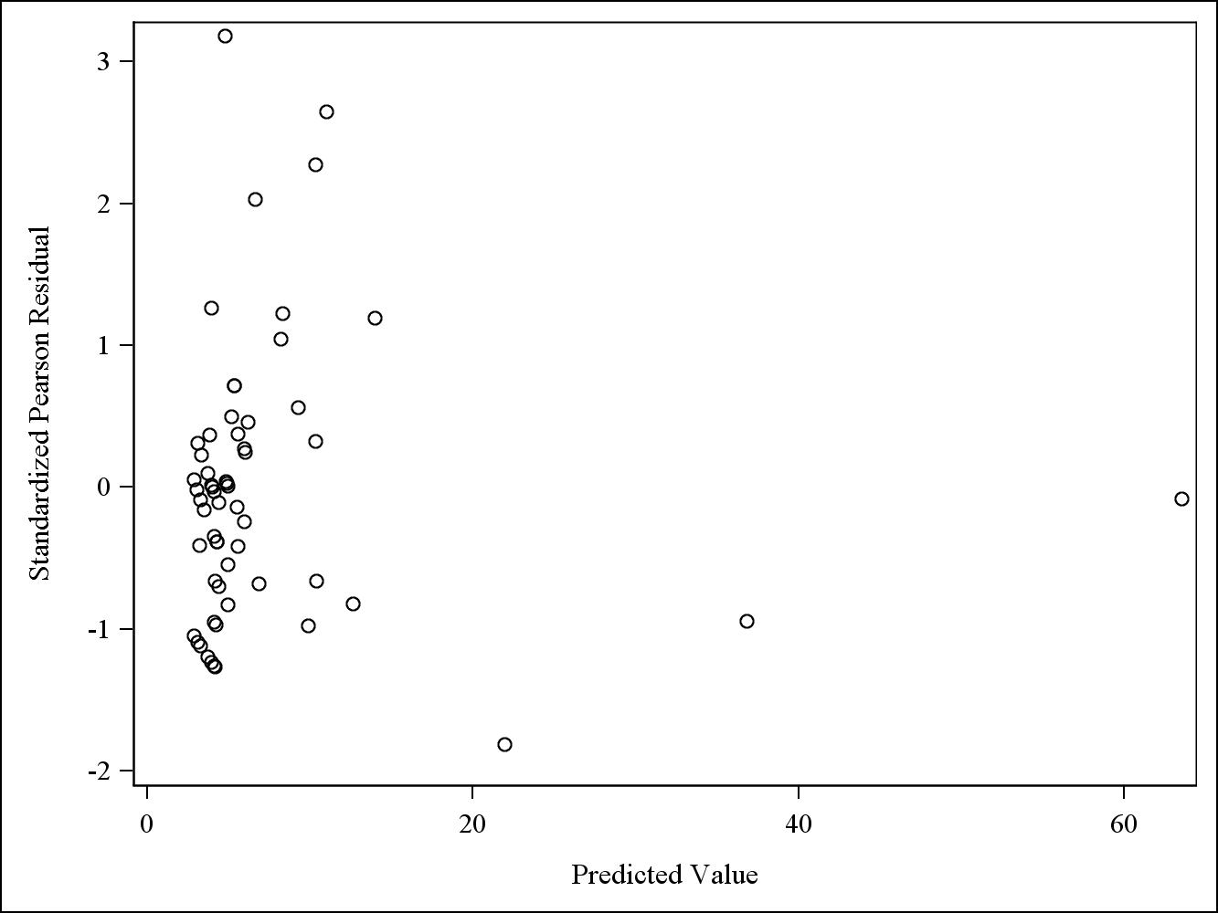

Since there are a few very large predicted values, it’s difficult to discern whether there are any trends in the residuals. The plot will be constructed again with predicted values less than 20.

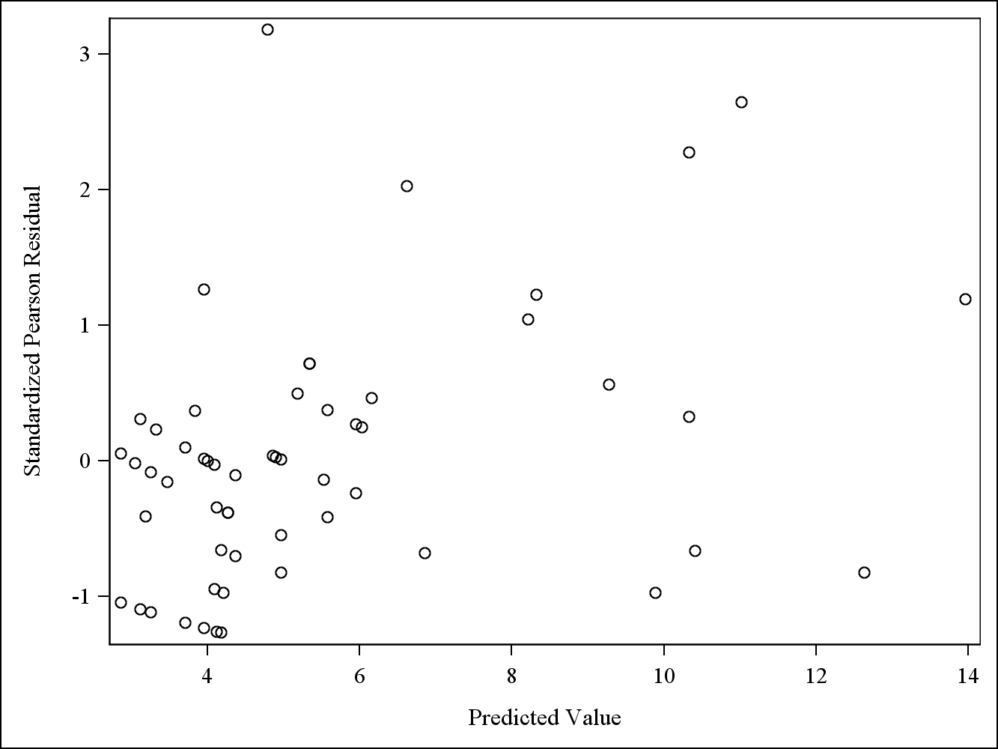

There does appear to be a slight upward trend of Perason residuals vs predicted values, which could indicate some potential problems with model assumptions.

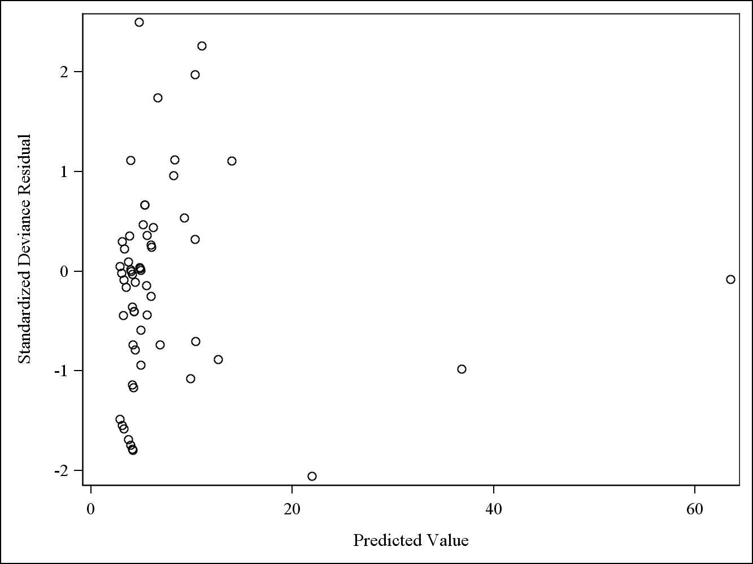

Since there are a few very large predicted values, it’s difficult to discern whether there are any trends in the residuals. The plot will be constructed again with predicted values less than 20.

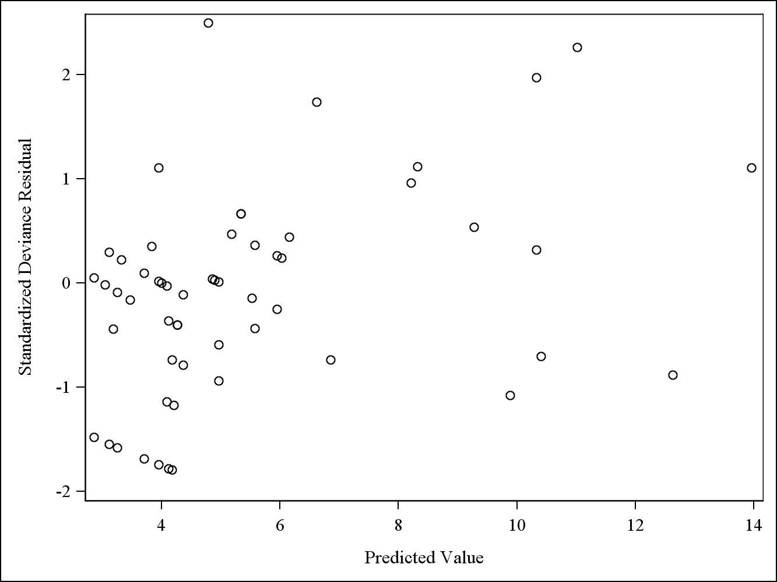

Similar to the Pearson residual plot, the deviance residual vs predicted value plot also appears to have a slight upward trend of residual values as predicted values increase. This could indicate some problems with model assumptions.